



Renfrewshire Coucil

Little Pandas Nursery

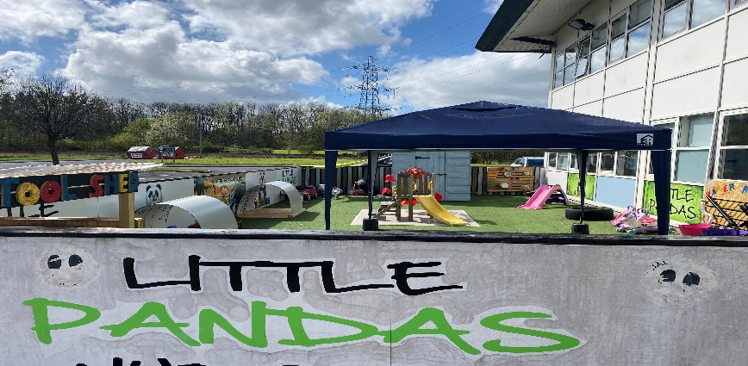

STANDARDS AND QUALITY REPORT

June 2022

This report will inform you of the establishment’s progress and achievements in the last session and let you know about our plans for 2022-2023. I hope that you find it helpful and informative.

**Head of Nursery -** Jennifer McNaughton

**SUCCESSES** **AND ACHIEVEMENTS**

* We have successful navigated the Nursery through Covid with very minimum distribution to all staff, children, and parents.
* At the start of the year (January 2022), we had our Care Inspector Inspection, and we are beyond delighted that our grades are now “good” therefore this supports our new Management team and the new ways of working that we have been implement.
* The new Management team have supported stability across the workforce and monthly celebrate staff successes from feedback from parents, staff, and management.
* All staff undertake monthly Staff training which is beneficial to their practice.
* Our outdoor learning and facilities have been developed and embedded within the Nursery. Recently a staff member has completed the Kindergarten Forestry Course.
* The Nursery has a daily focus on Health and Wellbeing across the whole Nursery as we follow and implement “setting the table” and “our world outdoors” when planning experiences. This is all based on the children’s interested, and these documents are also imbedded in the staff’s daily routine.
* In the past few months, all staff within the 3 – 5 department have been developing our home link learning. We have created numeracy, literacy and travelling ted. These three areas link back to the curriculum for excellence areas. This has further supported our parental involvement as well as collaborative working with parents.

**OUR CENTRE/NURSERY**

Little Panda’s was established in 2014 and underwent a re-registration process in 2020. It is open 50 weeks from 7.30am – 6pm and is registered for 108 children. The nursery is situated in Erskine near the riverfront and is surrounded by lush green space. We are easily accessed on foot or by car from all local areas and is near the bus station providing access for those who do not drive.

Our premises provides a modern, safe, comfortable environment for children aged 6 weeks – 5 years; with spacious bright playrooms, all complete with modern equipment, and a variety of age and stage appropriate toys and resources for learning and development. Children have access to outdoor play in the nursery gardens and regular outings within the local area. 1140hrs Childcare Funding is available for all children aged 3yrs+ and eligible 2yr olds.

**OUR VISION, VALUES AND AIMS**

* We are committed to offering high quality Early Learning and Childcare to every child that attends our nursery. Promoting the development of children’s intellectual, physical, social, and emotional needs from pre-birth to five.
* To create & provide a safe, warm, caring, happy, loving environment that promotes play.
* To treat each child as individuals (GIRFEC).
* To build relationships with each child, allowing them to develop and grow in a comfortable, stimulating, & safe environment.
* To develop children's potential, enabling them to become independent and to develop positive attitudes towards family, community, and learning.
* Encourage each child to reach their full potential through taking part in stimulating activities that foster their social interaction, communication, self-confidence, and self-worth.
* To foster a trusting and communicative relationship between children, parents, and staff.

**HOW SUCCESSFUL HAVE WE BEEN IN IMPROVING OUR NURSERY?**

**Leadership -** The new management team have worked hard to support and develop all staff within the Nursery to ensure they fully understand their role and the affects it has on the children in their care. The new manager has employed a new Deputy and promoted room seniors from within the Nursery who all either have or are working towards their SVQ Level 4 and over the past few months the team have developed a good working professional relationship which has GIRFEC (Getting it right for every child) at the centre of it. As a new Management team, we also created and follow our Staff and Nursery wellbeing policy which focuses on everyone’s physical, emotional (and mental), social and spiritual areas and under the curriculum covers children’s personal, social, emotional development and physical development.

**Workforce Professionalism -** Here at Little Pandas, we take confidentially very seriously and ensure all staff are up to date with current GDPR and all strive for best practice within all areas of the Nursery. Each month, three policies get reviewed and we seek for children’s and staff’s input. All staff are encouraged and supported to complete inhouse training to further develop their skills which effectively support children to reach their full potential. The staff team also engage in training relating to new approaches and policy from the local authority and government. Within this year, the team have undertaken training Day One Child Protection and ACE’s training along with Planning in the Moment from Anna Ephgrave. All staff have been given a staff uniform and they agree that this makes them feel part of a team and encourages a sense of belonging to the Nursery.

**Parental Engagement -** We have recently developed home link bags and travelling ted which supports our home links as parents take photos and share this with the team and playroom. Recently we have just undergone Parents nights and sent out two parent’s questionnaires to identify where we are and what parents believe we need to develop. Within the past few months all rooms have created Closed Facebook pages where we post daily photos of experiences within the playroom. We have continued with our daily what’s app communication and since the covid rules have developed we have reviewed and resent our open-door policy to all parents. We are at the very early stages of starting up a Parents Teacher Association (PTA) with six families ready to support us and attend our first meeting late in June.

**Assessment of Children’s Progress -** As a new management team, we are at the start of our journey to improve this especially as this was identified in our most recent inspection. As of April, all children have between one to three achievable and meaningful targets which have been agreed with all parents from the parents’ nights and this will be reviewed and documented every three months. All staff within the 3 – 5 department have been trained and use the summative assessment / progression tool kit as stated by Renfrewshire Council. At the start of the year, we moved back to spontaneous and responsive planning to give all staff the support and help with their planning, observation, and evaluation skills. We have embedded children’s interests ‘what I have done’ and observations sheets that are meaningful and individual to each child and all staff are comfortable with their planning.

**Establishment Improvement -** Our old football pitch has been converted into a learning environment as well as our baby garden. **T**hroughout the Nursery we have improved our Literacy and Numeracy offering which supports meaningful learning opportunities which links to early literacy and numerously skills in a natural environment.

**Performance Information -** We value feedback on our service from all stakeholders and have established a range of methods to gather this information to inform our improvement priorities. The use of online questionnaires has been effective in gathering views from families and practitioners on specific aspects of our provision. During the period of lockdown, the staff team engaged in a comprehensive review of our service using the quality indicators from ‘How Good is our Early Learning and Childcare’.

KEY STRENGTHS OF THE SCHOOL



















**KEY STRENGTHS**

**Communication** with staff and parents. This was highlighted in April’s questionnaire completed by staff and parents alike. As a management team, we aim to send out a weekly communication to parents via emails and have done this since January and we use the main Facebook page as a reference tool. The closed Facebook pages for each room, allows parents to see their child and friends interacting in the Nursery setting and we try to post daily and have a what’s app messenger page for each room where we communicate with parents daily. For staff, we post everything that we are sending out to parents, provide details of staff training and any other additional information they may require.

**Relationships** with the parents and children especially key worker children. This came through in our recent Care Inspector report and again in the parents’ questionnaire that we sent out in April.

**Nurturing Environment,** our rooms are spacious, offer a warm welcoming feeling and are well resourced with age-appropriate resources. We know this from feedback gathered from new families and the feeling they get when they have a tour of the Nursery and then sign their child up.



**OUR NEXT STEPS – PRIORITIES FOR 2022-23**

The challenges associated with the Covid 19 pandemic continued to hinder our progress and our ability to achieve all our improvement priorities. Some priorities and actions will therefore be carried forward to academic session 2022 – 23. We believe that we have made **good** progress during session 2021-22 and we will use the improvement priorities listed below to build on this progress moving forward.

**Continued from 2021 – 2022**

An overview from management and staff is that we should improve our approaches to self-evaluation as this was not achieved in the 2020 – 2021 Improvement Plan. This should be achieved via consultation with children, parents, and staff to enable everyone to have a clear voice and viewpoint with regards to the service delivery.

**New 2022 - 2023**

As the new management team have only been in place for a few months along with the new planning and observation sheets, as a Nursery we need to continue to ensure all staff and children are supported with these which in turn will ensure each child has the potential to achieve and develop across the curriculum.

Since one of our staff members is newly qualified in Kinder Forestry, as a Nursery we see the benefits that our children gain from outdoor play and that we have embedded outdoor play in our daily life. With all the positive benefits from outdoors and with our below average score on the progression tool for literacy we are going to focus on improving literacy outdoors. Going forward we will ensure each outdoor session includes the indoor planning and observations which follow the children’s interest.

*Full details of the establishment’s improvement priorities and actions are detailed on the establishment improvement plan.*

**HAVE YOUR SAY!**

Please take the opportunity to share your thoughts with us as we use feedback to help us make improvements to the establishment. You can do this by speaking to staff, participating in parent/career meetings, responding to questionnaires/surveys and by completing evaluations at events.

**Little Pandas Nursery**

**53 Kilpatrick Drive, ERSKINE, PA8 7AF**

**0141 812 4002**

<http://www.littlepandasnursery.co.uk>

[Little Panda's Nursery | Facebook](https://www.facebook.com/littlepandasnursery)

**School Name**

**School Address**

**Phone**

**Fax**

**Website**

**Twitter/Facebook**